Research Title:
Associated Factors and Knowledge gap About Type 2 Diabetes among Non-Medical University Students in Southern Iraq

Saman A Hashim^{1*}, Ja’far M. Alkhawaldeh², Atheer K Ibadi³, Mohd Y Barakatun-Nisak^{4,5}, Haider A Alidrisi⁶, Abbas A Mansour⁷, Ibrahim A Zaboon⁸

- Assistant Prof., Department of Community Health, Technical Medical Institute in Basrah, Southern Technical University, Basrah, Iraq; Email Address: saman.hashim@stu.edu.iq, ORCID: 0000-0003-0144-137X
- Associate Professor, Faculty of Nursing, Isra University, Amman, Jordan; Email Address: khawaldeh.j@iu.edu.jo, ORCID: 0000-0001-9419-072X
- Professor, Pharmacy Department, Kufa Institute, Al-Furat Al-Awsat Technical University, Iraq; Email Address: kin.ath@atu.edu.iq, ORCID: 0000-0001-8635-1052
- Assistant Prof., Department of Dietetics, Faculty of Medicine and Health Sciences, Universiti Putra Malaysia, Serdang, Malaysia; Email Address: bnisak@upm.edu.my, ORCID: 0000-0003-0403-5895
- Institute for Social Sciences Studies, Universiti Putra Malaysia, Serdang, Malaysia.
- Assistant Prof., Faiha Specialized Diabetes, Endocrine, and Metabolism Center (FDEMC), University of Basrah, Basrah, Iraq; Email Address: haider.alidrisi@fdemc.iq , ORCID: 0000-0003-3132-1758
- Professor, Faiha Specialized Diabetes, Endocrine, and Metabolism Center (FDEMC), University of Basrah, Basrah, Iraq; Email Address: abbas.mansour@fdemc.iq, ORCID: 0000-0001-8083-6024
- Medical Doctor, Faiha Specialized Diabetes, Endocrine, and Metabolism Center (FDEMC), Basrah Health Directorate, Basrah, Iraq; Email Address: dr.ibraheem2@gmail.com, ORCID: not available.
* Corresponding Author
Saman Agad Hashim, RDN, PhD. Community Health Department, Technical Medical Institute in Basrah, Southern Technical University, Zubair Main Street, Basrah City, 61001, Iraq; Email Address: saman.hashim@stu.edu.iq, phone: +9647802180217, ORCID: 0000-0003-0144-137X, Scopus ID: 57219440845, Web of Science Researcher ID: KFR-5169-2024
ABSTRACT
Background: Lifestyle changes and low knowledge contribute to the rising prevalence of type 2 diabetes (T2D). Thus, this study aims to assess diabetes-related knowledge, attitudes, and practices (KAP) and knowledge-associated factors among non-medical university students in Iraq.
Methods: This is a cross-sectional study that utilises a validated, structured questionnaire in Arabic. A multi-stage sample of 378 university students (mean age is 24.7±6.9 years) was recruited and interviewed. SPSS version 25 was utilized.
Results: The study showed a moderate level of knowledge (54.1%), with significant gaps in management of diabetes. Only 24.9% reported that T2D was incurable. Attitudes were generally positive (75.9%), but 42.9% underestimated the severity of T2D. Practices were suboptimal (66.8%), with only 45.5% checking their blood glucose and 27.5% reported physical inactivity. Higher KAP scores were among older age, male gender, marital status, family history of T2D, attendance at diabetes workshops, higher school, and reliance on medical staff information, which explained 24.5%, 12.0%, and 22.2% of the total variance in KAP scores respectively.
Conclusion: Older age, male sex, marital status, higher academic year, family history of T2D, attendance at diabetes-related workshops, and reliance on medical staff for information were associated with better KAP scores.
Keywords: Type 2 diabetes, knowledge, attitudes, practices, university students, Iraq.

Introduction
Type 2 diabetes (T2D) represents one of the most pressing global public health challenges, with its prevalence rising disproportionately in low- and middle-income countries (LMICs), including Iraq [1]. The growing burden of T2D is attributed to lifestyle changes, poor dietary habits, and low knowledge of risk factors [2]. While healthcare professionals are well-informed about T2D prevention and management, non-medical populations, particularly university students, often lack sufficient knowledge about the disease [3]. In Iraq, where urbanization and shifting dietary patterns may contribute to T2D risk [4, 5], understanding the associated factors of T2D knowledge among non-medical university students is crucial for developing targeted interventions [6].

Despite the increasing prevalence of T2D in Iraq, Only one education tool was developed in Basrah, Iraq, to ​​promote diabetes knowledge [7], but it was not sufficient as an educational program in this region, there remains a significant gap in knowledge, as well as risk perception and practices about the disease, especially among young adults outside the healthcare sector [8]. University students, who represent a key demographic for preventive health strategies, may lack essential knowledge about T2D risk factors, symptoms, and complications [9]. This knowledge gap could lead to delayed diagnosis, poor lifestyle choices, and higher susceptibility to the disease [10, 11]. However, limited research has explored the associated factors of T2D knowledge and the extent of this knowledge gap among university students, particularly in Southern regions of Iraq, making this study crucial for public health planning. A study in Saudi Arabia found that only 46.0% of university students could correctly identify T2D symptoms and pathophysiology [3]. Similar trends were observed in Algeria [12] and Jordan [13], where non-medical students showed poor knowledge of preventive measures.
Despite growing awareness of the need for health education in Iraq, including topics such as diabetes, it is not consistently integrated into school curricula. This indicates a significant gap in knowledge about diabetes among various population groups, including students[14] . By examining factors such as socio-demographic characteristics, family history of T2D, academic year, and sources of health information, the findings will provide valuable insights for public health policymakers and educators [15]. The study's results can guide the development of educational initiatives and tailored knowledge strategies to enhance understanding of T2D, encourage proactive prevention, and alleviate the projected rise in T2D cases within this at-risk group. Improving knowledge among university students could yield lasting health improvements and help curb the expanding T2D crisis in Iraq. The Null Hypothesis (H₀) in current study is "There is no significant association between sociodemographic factors (age, gender, academic year, family history of diabetes, attendance at diabetes workshops, and source of health information) and diabetes-related knowledge, attitudes, and practices (KAP) among non-medical university students in southern Iraq". Thus, this study aims to assess diabetes-related knowledge, attitudes, and practices (KAP) and explore the associated factors among non-medical university students in southern Iraq.

Methodology

Study Design
This study employs an analytic cross-sectional study design to assess the knowledge, attitudes, and practices (KAPs) related to type 2 diabetes (T2D) among non-medical university students in Basrah, Iraq, from October 2024 to April 2025, In compliance with the Strengthening the Reporting of Observational Studies in Epidemiology (STROBE) guidelines for cross-sectional studies [16].

Study Population
Due to several faculties which included several departments, the multistage sampling method was used, the study targets 378 different non-medical university students from University of Basrah and Southern Technical University included engineering 35%, arts 11%, sciences 34, and other non-medical disciplines 20% which providing education for both deploma and bachelor degrees in Southern Iraq. Inclusion criteria included non-medical undergraduates aged 18–30 years old. The exclusion criteria included medical or healthcare students, those who did not wish to participate in the study, and those diagnosed with T2D according to the American Diabetes Association guidelines [17].

Study instrument
A structured questionnaire with closed-ended questions that were valid among Arab people was adopted [15] and modified before being utilized, consisting of the following sections: the first section is socio-demographic and mediocal information that included age per years, sex, academic level (1st, 2nd, 3rd, or 4th), Body weight and height were utilized to compute the Body Mass Index (BMI), and the patient's weight status was categorized in accordance with World Health Organization (WHO) standards [18]. A Body Mass Index ranging from 18.5 to 24.9 kg/m² is categorized as normal, whereas a Body Mass Index between 25 and 29.9 kg/m² signifies overweight, and a Body Mass Index of 30 kg/m² or higher is classified as obesity [18]. Also include family history of T2D (yes, or no), and source of health information (Internet, TV, Friends, Medical staff, Reading, and Family). In addition, questions were asked about checking blood glucose levels (yes, or no), participating in diabetes-related activities (yes, or no), and caring for a relative with T2D (yes, or no).

The second section is the knowledge assessment that consists of 22 questions [15], eight multiple-choice questions with one correct answer, and 14 yes/no/don't know questions. Correct answers received one point, while incorrect or don't know answers received zero. Total scores ranged from 0 to 22 and were then converted to percentages. The highest score indicated the highest level of diabetes-related knowledge [3]. Knowledge items included diet (6 questions), medications (3 questions), physical activity (3 questions), T2D complications (2 questions), weight gain (1 question), and the definition, course, measurements, signs, and symptoms of T2D (7 questions).

The third section is about attitudes (risk perceptions) assesment toward T2D using the following three questionsn[15]: "How likely are you to develop T2D within the next few years if you do not change your lifestyle?" "Do you think people your age are at risk of developing T2D?" and "Do you think T2D is a serious health problem?" Participants answered on Likert scale points (high = 4, moderate = 3, weak = 2, or "not statistically significant = 1"). Responses were summed up to the three risk perception items [15] to form a threat perception scale, with a total score ranging from 3 to 12, which were converted into percentages. Similarly, the forth section is practice assessment using seven items [15], with participants asked to respond on a four-point Likert scale (always = 4, sometimes = 3, rarely = 2, or never = 1). Item 7 was reverse-scored to the other items. It was given Likert scores (always = 1, sometimes = 2, rarely = 3, or never = 4). Total scores ranged from 4 to 28 and were then converted to percentages. Participants were asked to select the source of information about T2D (Internet, TV, Friends, Medical staff, Reading, and Family) they used most often (only one source).

Scoring of KAPs
Knowledge Section: To assess understanding of T2D causes, symptoms, complications, and management. The scoring method assigns 1 point for each correct answer and 0 for incorrect/don't know. Sum scores for a total knowledge score (e.g., 10 questions → max score = 10). Categorized knowledge levels are poor (≤50% correct), moderate (51–75%), and good (>75%).

Attitudes Section: To gauge perceptions, beliefs, and emotional responses toward T2D. The scoring method uses a Likert scale (e.g., 1–5 points per item): Strongly disagree (1) to strongly agree (5) for positive statements and reverse-score negative statements (e.g., " T2D is not serious"). The total attitude score is the sum of all item scores. Higher scores indicate more positive attitudes. So, the categorized attitudes are negative (lower tertile), neutral (middle tertile), and positive (upper tertile).

Practices Section: To evaluate behaviors related to T2D prevention/management (e.g., diet, exercise, medication adherence). The scoring method is frequency-based scoring: Never (0) / Sometimes (1) / Often (2) / Always (3). The total practice score is the sum of all points. Higher scores indicate better practices. So, the categorize practices are Poor (≤50% of max score), Fair (51–75%), and Good (>75%).

Data Collection
The questionnaire was validated through expert review and a pilot study (n=30) to assess clarity and reliability (Cronbach's alpha = 0.87). The study was administered through paper-based questionnaires in university settings. Participants were given a maximum of 15 minutes to complete the questionnaire. The researchers collected data in a quiet, comfortable classroom to ensure accurate measurement of their actual knowledge, attitudes (beliefs), and practices. To address potential sources of bias, students were asked to avoid access to their books, notebooks, or the internet or to discuss the questions with their classmates. After the allotted time had elapsed, we collected the questionnaires and stored them in a secure cabinet until the end of the data collection period. Data was collected over 7 months, ensuring a diverse representation of students across faculties.

Data Analysis
Data was analyzed using a statistical package for the social sciences (V.25.0, IBM, SPSS, Chicago, Illinois, USA) with the following statistical approaches. Descriptive statistics include frequencies, percentages, mean, and standard deviation for demographic and KAP variables. Inferential statistics also included the Chi-square or Fisher's exact test to assess associations between demographic factors and KAP levels. A one-way between-groups analysis of variance (ANOVA) was used to investigate the impact of variables with more than two groups. A post hoc analysis with Hochberg's GT2 was used to identify which group was more effective when group sizes were extremely unequal. Pearson's Correlation measures linear relationships between continuous variables (e.g., KAPs score). Finally, stepwise multiple linear regression models (p in < 0.05, p out > 0.20) were ﬁtted to explore the factors inﬂuencing the level of diabetes-related KAP. Missing data were manually addressed for each variable. A p-value <0.05 (two-tailed) was considered to be signiﬁcant.

Results
To avoid the potential sources of bias, a multistage sampling method was utilized to select participants. Initially, the researcher randomly selected 12 of the 28 colleges and institutes. Four classes were chosen for each semester. Approximately 10 students were selected from each class, bringing the total number of students enrolled in the confidential interviews to 480. However, 58 students withdrew due to lack of interest, leaving 422 participants who submitted questionnaires to trained researchers. After review, 378 questionnaires were deemed valid, meaning they had fewer than four missing items [19], so the response rate is 79% (Figure 1). Therefore, the study included 378 participants (mean age = 24.7 years, SD = 6.9), with a nearly equal sex distribution (50.8% males, 49.2% females).

According to the findings of this study we have to reject the null hypothesis. Most participants were singles (75.7%) and enrolled in undergraduate programs, with the highest representation from the second academic year (37.0%). Most fell within the normal weight (45.5%) or overweight (43.9%) categories, while 6.8% were obese. Regarding diabetes-related Knowledge attitudes and Practices (KAPs), the mean scores indicated moderate knowledge (M = 54.1, SD = 15.9), positive attitudes (M = 75.9, SD = 12.8), and suboptimal practices (M = 66.8, SD = 13.9). The correlation coefficient was not significant among KAP scores. Nearly half of the participants reported a family history of type 2 diabetes (T2D) (45.0%), but only 22.2% had attended diabetes-related courses or workshops. Less than half (45.5%) had checked their blood glucose levels. Participants' involvement in T2D care varied: 40.2% had no experience, while 14.8% reported consistent caregiving. The primary sources of T2D information were the internet (41.8%), followed by family (28.6%) and medical staff (11.6%) (Table 1).

In Table 2, diabetes-related KAP scores were analyzed in terms of demographic and health-related variables. Participants aged >22 years had significantly higher Knowledge scores (M = 55.9, SD = 15.8) compared to those aged ≤22 years (M = 51.9, SD = 15.8; p = 0.014). Similarly, Practice scores were higher in the older age group (M = 68.9, SD = 12.9 vs. M = 64.3, SD = 14.7; p = 0.001). Males exhibited significantly higher Knowledge (M = 56.4, SD = 14.8) and Practices (M = 70.1, SD = 13.6) scores compared to females (Knowledge: M = 51.6, SD = 16.7, p = 0.003; Practice: M = 63.3, SD = 13.5, p < 0.001). Underweight participants had higher Knowledge scores (M = 57.2, SD = 16.9) than normal-weight (M = 53.2, SD = 15.6; p = 0.042) and overweight (M = 53.4, SD = 15.9; p = 0.048) groups. The obesity group had the highest Practice scores (M = 72.1, SD = 12.2), differing significantly from underweight (M = 56.6, SD = 13.3; p = 0.005) and normal-weight (M = 67.4, SD = 13.9; p = 0.032) groups. Married participants scored higher in Knowledge (M = 59.9, SD = 14.9 vs. M = 52.2, SD = 15.7; p < 0.001) and Practice (M = 69.5, SD = 13.1 vs. M = 65.9, SD = 14.2; p = 0.031) compared to single participants.

First-year students had lower Knowledge scores (M = 51.2, SD = 16.9) than third-year (M = 57.8, SD = 15.2; p = 0.051) and fourth-year (M = 55.6, SD = 15.8; p = 0.048) students. Attitude scores were highest among fourth-year students (M = 80.4, SD = 10.7), differing significantly from second-year (M = 73.2, SD = 13.9; p < 0.001) and third-year (M = 74.6, SD = 11.0; p = 0.027) students. Participants who attended T2D courses or workshops had higher Knowledge (M = 61.5, SD = 14.6 vs. M = 51.9, SD = 15.6; p < 0.001), Attitude (M = 78.8, SD = 11.6 vs. M = 75.2, SD = 13.1; p = 0.027), and Practice (M = 75.9, SD = 9.9 vs. M = 64.1, SD = 13.9; p < 0.001) scores. Those with a family history of T2D scored higher in Knowledge (M = 59.1, SD = 14.6 vs. M = 49.9, SD = 15.7; p < 0.001). In terms of T2D care experience, participants who never cared for T2D patients had lower practice scores (M = 63.7, SD = 13.5) compared to those who sometimes (M = 69.5, SD = 12.8; p = 0.005) or always (M = 69.2, SD = 16.2; p = 0.029) provided care. Asking medical staff as a source of information on T2D was associated with higher Practice scores (M = 70.6, SD = 14.3) compared to internet sources (M = 64.9, SD = 13.5; p = 0.003) (Table 2).
The study evaluated diabetes-related knowledge through a series of true/false questions. While 90.5% correctly identified T2D as a non-communicable disease, only 52.9% understood it as a condition of impaired insulin response. Just 24.9% recognized T2D as incurable, reflecting a prevalent misconception about disease management. 75.7% knew high blood glucose could damage organs, and 78.3% acknowledged weight loss as beneficial for T2D control. Only 38.1% correctly stated that high blood glucose reduces hunger, and 61.9% erroneously believed prediabetes implies normal blood glucose. 65.1% incorrectly thought oral T2D medications were insulin pills. 23.3% falsely believed people with T2D on medication need not regulate eating habits, and 36.0% asserted physical activity is unnecessary with medication. 74.6% recognized diet/exercise could avoid medication for T2D. Also, 92.6% wrongly assumed homemade bread was advised due to fiber content, and 84.1% did not know fats provide the highest energy. 57.7% identified the fasting blood glucose range (70–120 mg/dL) for diabetics. 72.5% correctly linked the lack of foot pain after injury to nerve damage (Figure 2).

Table 3 shows half of the participants (50.3%) believed T2D does not affect health, while 42.9% considered it not dangerous. Only 6.9% (1.6% hazardous + 5.3% dangerous) viewed T2D as a significant health threat. A majority (47.1%) perceived T2D as not hazardous for people their age, whereas 32.3% believed it had no effect. Only 20.6% (2.1% hazardous + 18.5% dangerous) considered it a serious risk. Most participants (42.3%) rated their likelihood of developing T2D as low, followed by middle (36.0%). Only 8.5% perceived a high risk, while 13.2% believed they had no risk. 42.3% of the participants reported controlling their weight most of the time as a preventive measure against T2D, and a combined 39.1% (19.0% never + 20.1% rarely) engaged in little to no weight management.
A majority (72.5%) exercised regularly (most times: 42.3%; always: 30.2%), but 27.5% (never: 9.5%; rarely: 18.0%) were inactive. Only 16.9% always consumed a balanced, low-glucose diet, whereas 38.9% did so most times. However, 44.2% (never: 14.3%; rarely: 29.9%) rarely followed such dietary practices. A significant proportion (56.3%) rarely or never sought diabetes-related advice from healthcare professionals. While 69.6% (most times: 43.9%; always: 25.7%) relied on accurate health information for lifestyle changes, 30.5% (never: 12.2%; rarely: 18.3%) did not. Most participants (68.6%) reported considering lifestyle changes most of the time. Over half (51.3%) expressed no interest in diabetes-related news (Table 3).

Multiple regression analyses were conducted to identify associated factors of diabetes-related KAP among university students (Table 4). The knowledge model explained 24.5% of the variance in knowledge scores (R² = 0.245, adjusted R² = 0.230). Students with a family history scored 8.48 points higher (B = 8.475, β = 0.267, p < 0.001). Students who had never checked their blood glucose scored 7.16 points lower (B = -7.158, β = -0.225, p < 0.001). Married students scored 4.95 points higher (B = 4.950, β = 0.133, p = 0.005). Third-year students scored 5.78 points higher (B = 5.777, β = 0.147, p = 0.002) than the reference group. Males scored 4.20 points higher (B = 4.202, β = 0.133, p = 0.004). Students who never attended T2D workshops or courses scored 4.07 points lower (B = -4.071, β = -0.106, p = 0.030). Relying on friends for T2D information was associated with 6.20 points lower knowledge (B = -6.201, β = -0.100, p = 0.032).

Table 4 shows the multiple regression model explained by 12.0% (R² = 0.120, Adjusted R² = 0.110) of variance in diabetes-related attitudes. Students who had checked their blood glucose showed more positive attitudes (B = 5.03, β = 0.196, p < 0.001). Those relying on family for T2D information had higher attitude scores (B = 5.60, β = 0.199, p < 0.001). Second-year students scored lower (B = -3.33, β = -0.126, p = 0.018). While fourth-year students scored higher (B = 3.50, β = 0.110, p = 0.041).

The model accounted for 22.2% (R² = 0.222, Adjusted R² = 0.210) of variance in T2D prevention practices. Non-attendees had significantly poorer practices (B = -12.60, β = -0.372, p < 0.001), representing a large effect size. Males reported better practices (B = 5.36, β = 0.192, p < 0.001). First-years showed strongest practices (B = 8.18, β = 0.245, p < 0.001). Also, Second-years maintained better practices than the reference group (B = 5.22, β = 0.181, p = 0.001). Underweight status predicted poorer practices (B = -8.48, β = -0.116, p = 0.013), while older age showed small but significant benefits (B = 0.33/year, β = 0.127, p = 0.014) (Table 4).

Discussion
This study provides critical insights into diabetes-related knowledge, attitudes, and practices (KAP) among university students in southern Iraq, revealing both strengths and significant gaps in type 2 diabetes (T2D) knowledge and preventive behaviors. Below, the results are discussed in relation to the study objective, which was to assess knowledge, attitudes, and practices related to diabetes among university students and to identify demographic and health factors that influence these outcomes. The moderate knowledge of 54.1% and prevalent misconceptions (e.g., only 24.9% recognized T2D as incurable) mirror findings from Saudi students [3], where actual knowledge scores were similarly suboptimal at 46.0%. Both studies identified gaps in understanding T2D pathophysiology and medication, with 65.1% of Iraqi students incorrectly believing oral medications are "insulin pills," a misconception also noted among Saudi nursing students [3]. These parallels suggest systemic issues in health education across the region, possibly due to curricular limitations or inadequate emphasis on T2D mechanisms [13].

However, these findings were lower compared to a study conducted in Kuwait [20] and Palestine [21] among students, whose knowledge scores were 63.2% and 78.0%, respectively. The discrepancy in the results between this study and the previous studies could be attributed to several factors, possibly robust health education programs in secondary schools, the different assessment questions, which were easier and more familiar terminology, leading to better knowledge scores in the previous studies.

The study reported a positive attitude of 75.9%, though 42.9% underestimated T2D severity. This finding is better if compared with neighboring countries like Jordan (46.3%) [13] and Jourdan (52.5%) [15] and Palestine (60.6%) [21], possibly due to cultural perceptions or lack of targeted education and difference period between studies, but was lower compared with a Saudi study [22] (83.3%) mirrored the current research. Positive attitudes may not always align with knowledge, highlighting the need for interventions that bridge this gap.

Practices were suboptimal 66.8%; only 45.5% checked blood glucose, 27.5% were inactive, and 56.3% rarely sought professional advice. Similar findings were seen in a study conducted in the United States of America [23], where physical inactivity and poor dietary habits were common, indicating low engagement in preventive practices in these studies, as well as in the United Arab Emirates, the knowledge was 70.0% [24]. Still, practices like regular exercise were poor (only 27% exercised regularly). However, a Pakistani study reported that only 25.2% had ever checked blood glucose, closely matching the current study's low screening rates. All studies identified a gap between knowledge and practice, particularly in physical activity and preventive measures like blood glucose monitoring. The current study's suboptimal practices mirror findings from the United Arab Emirates and the United States of America, emphasizing the need for interventions that bridge this gap.

The current study and Yaaqoob (2023) in Iraq [6] found older students had higher knowledge scores, likely due to cumulative education and experience. Males in the current study had higher knowledge and practice scores, contrasting with Gazzaz (2020) [22] and Asmar (2024) [21], where females scored higher. This discrepancy may reflect cultural differences in health education access. Family History of T2D is consistently linked to better knowledge and practices. This finding agrees with Asmar (2024) [21] and Yaaqoob (2023) [6], emphasizing the role of personal exposure. It was also associated with negative attitudes, possibly due to heightened risk perception [15]. Attendance at T2D workshops or courses significantly boosted knowledge and practices, emphasizing the need for targeted educational interventions [3]. However, its impact on attitudes was negligible, suggesting that attitudes may require more nuanced approaches, such as peer-led initiatives or experiential learning [22].

Notably, the academic year showed mixed results. While higher years were linked to better knowledge [3], this did not always translate to improved attitudes or practices, indicating gaps in curriculum integration [15]. Primary sources of Information on T2D were the Internet (41.8%), family (28.6%), and medical staff (11.6%). These findings coincide with a study conducted in Algeria [12] among Algerian university students. Where the Internet/social media (41.7%) and family/friends (25.4%) were the primary sources, with healthcare providers being less common (12.7%). The reliance on informal sources (Internet, family) over healthcare providers is a common theme, suggesting a need for more authoritative and accessible health education channels.

Strength and limitation of the study
The study's strengths include a diverse sample and comprehensive KAP assessment, as well as a multistage sampling method, was used to avoid bias. However, the cross-sectional design limits causal inferences, and self-reported data may introduce bias. The reliance on internet-based information (41.8%) as a primary knowledge source may raise concerns about information quality.

Conclusion
This study highlights moderate diabetes-related knowledge, positive attitudes, and suboptimal practices among non-medical university students in southern Iraq, with significant gaps in understanding the pathophysiology, curability, and management of type 2 diabetes (T2D). Key associated factors of better diabetes-related KAP scores included older age, male gender, marital status, higher academic year, family history of T2D, attendance at diabetes-related workshops, and reliance on medical staff for information. These findings underscore the need for specific educational interventions to enhance diabetes awareness, particularly in terms of disease severity, prevention, and self-management practices. Strengthening health promotion initiatives such as university-based workshops and accessible medical guidance could enhance KAP levels and help curb the growing burden of T2D among young adults in Iraq and similar populations.

Funding information: Not applicable.

Conﬂicts of interest Statement: The authors have none to declare.

Ethical issues: Ethical approval was obtained from the study received approval from the Medical Ethical Committee and Scientiﬁc Research Unit of Southern Technical University (IRB-STU 7/27/199 of October 10, 2024). Also, participation was voluntary, and anonymity will be maintained. Students were provided with the necessary information about the study, and participants signed an informed consent form. The researchers explained to the participants that their participation was voluntary and would not affect their university performance. The study was conducted following the Helsinki Declaration on Medical Research Ethics.

Acknowledgments: Not applicable.

Authors’ Contribution
Conception and design: Saman A Hashim, Ja’far M. Alkhawaldeh, & Atheer K Ibadi.
Acquisition of data: Saman A Hashim
Analysis and interpretation of data: Ibrahim A Zaboon.
Drafting of the manuscript: Saman A Hashim, Ja’far M. Alkhawaldeh, & Atheer K Ibadi.
Critical revision of the manuscript for important intellectual content: Abbas A Mansour
Statistical analysis: Saman A Hashim, & Abbas A Mansour.
Obtaining funding: Saman A Hashim
Administrative, technical, or material support: Saman A Hashim
Supervision: Saman A Hashim, Mohd Y Barakatun-Nisak, & Haider A Alidrisi
Writing–review & editing: Saman A Hashim, Ja’far M. Alkhawaldeh, Atheer K Ibadi, Mohd Y Barakatun-Nisak, Haider A Alidrisi, Abbas A Mansour, & Ibrahim A Zaboon.
References
1. Hossain MJ, Al-Mamun M, Islam MR: Diabetes mellitus, the fastest growing global public health concern: Early detection should be focused. Health science reports 2024, 7(3):e2004.
2. Forray AI, Coman MA, Simonescu-Colan R, Mazga AI, Cherecheș RM, Borzan CM: The Global Burden of Type 2 Diabetes Attributable to Dietary Risks: Insights from the Global Burden of Disease Study 2019. Nutrients 2023, 15(21).
3. Alsolais AM, Bajet JB, Alquwez N, Alotaibi KA, Almansour AM, Alshammari F, Cruz JP, Alotaibi JS: Predictors of Self-Assessed and Actual Knowledge about Diabetes among Nursing Students in Saudi Arabia. Journal of personalized medicine 2022, 13(1).
4. Hashim SA, Barakatun-Nisak MY, Abu Saad H, Ismail S, Hamdy O, Mansour AA: Association of Health Literacy and Nutritional Status Assessment with Glycemic Control in Adults with Type 2 Diabetes Mellitus. . Nutrients 2020, 12, 3152 2020.
5. Hwalla N, Jaafar Z, Sawaya S: Dietary Management of Type 2 Diabetes in the MENA Region: A Review of the Evidence. Nutrients 2021, 13(4).
6. Yaaqoob BY, Kadhem SA: Evaluating the Level of Knowledge of University Students about Diabetes Mellitus. Health Education and Health Promotion 2023, 11(1):173-180.
7. Hashim SA, Al jassim NH, Mansour AA: Development of Simplified Diabetes Nutrition Education Tools for Patients with Type 2 Diabetes Mellitus in Basrah, Iraq. International Journal of Nutrition Sciences 2025, 10(2):314-324.
8. Abusaib M, Ahmed M, Nwayyir HA, Alidrisi HA, Al-Abbood M, Al-Bayati A, Al-Ibrahimi S, Al-Kharasani A, Al-Rubaye H, Mahwi T et al: Iraqi Experts Consensus on the Management of Type 2 Diabetes/Prediabetes in Adults. Clinical medicine insights Endocrinology and diabetes 2020, 13:1179551420942232.
9. Sękowski K, Grudziąż-Sękowska J, Pinkas J, Jankowski M: Public knowledge and awareness of diabetes mellitus, its risk factors, complications, and prevention methods among adults in Poland-A 2022 nationwide cross-sectional survey. Front Public Health 2022, 10:1029358.
10. Pragya Mangla NRHKSVM: Diabetes awareness: Significant knowledge gap among medical and nursing students in Delhi. South Eastern European Journal of Public Health 2025:993-1004.
11. Hashim SA, Mohd Yusof BN, Abu Saad H, Ismail S, Hamdy O, Mansour AA: Effectiveness of simplified diabetes nutrition education on glycemic control and other diabetes-related outcomes in patients with type 2 diabetes mellitus. Clin Nutr ESPEN 2021, 45:141-149.
12. Lounis M: Assessment of diabetes related-knowledge and practice among Algerian university students: a cross-sectional survey. Discover Public Health 2024, 21(1):66.
13. Alsous M, Abdel Jalil M, Odeh M, Al Kurdi R, Alnan M: Public knowledge, attitudes and practices toward diabetes mellitus: A cross-sectional study from Jordan. PLoS One 2019, 14(3):e0214479.
14. Abdul Karim RA, Habib HA: Awareness Regarding Diabetes Risk Factors, Prevention and Management among Community Members in Diyala/Baqubah. AL-Kindy College Medical Journal 2022, 18(1):24-29.
15. Khlaifat AM, Al-Hadid LA, Dabbour RS, Shoqirat N: Cross-sectional survey on the diabetes knowledge, risk perceptions and practices among university students in South Jordan. J Diabetes Metab Disord 2020, 19(2):849-858.
16. Austrian Development Agency EU: Guidelines for Project and Programme Evaluation, 2009., vol. final draft: Austrian Development Agency, Evaluation Unit. Vienna, October 2008 2009.
17. Association AD: Diagnosis and Classification of Diabetes: Standards of Care in Diabetes—2024. Diabetes Care 2023, 47(Supplement_1):S20-S42.
18. WHO: The International Classification of adult underweight, overweight and obesity according to BMI. In., APRIL 2018 edn: WHO; 2004.
19. Xu Y, Zhang D, Liu K, Guo Y, Yang Y: Self-reported knowledge on diabetes and its related factors among Chinese college students: a cross-sectional study. BMJ Open 2016, 6(9):e011963.
20. Al-Hussaini M, Mustafa S: Adolescents’ knowledge and awareness of diabetes mellitus in Kuwait. Alexandria Journal of Medicine 2015, 771.
21. Asmar I, Almahmoud O, Qoud B, Assaf M, Saleh A, Alyan A, Dahabrah N: Diabetes knowledge, attitudes and practices among university students in a developing country. Journal of Diabetes Nursing 2024, 28:333.
22. Gazzaz ZJ: Knowledge, Attitudes, and Practices Regarding Diabetes Mellitus Among University Students in Jeddah, Saudi Arabia. Diabetes Metab Syndr Obes 2020, 13:5071-5078.
23. Johnson C ON: Assessing Diabetes Knowledge, Attitudes and Behaviors of College Students. Am J Med Public Health 2020, 1(2): 1007.
24. Khan N, Gomathi KG, Shehnaz SI, Muttappallymyalil J: Diabetes Mellitus-Related Knowledge among University Students in Ajman, United Arab Emirates. Sultan Qaboos University medical journal 2012, 12(3):306-314.

Figures:
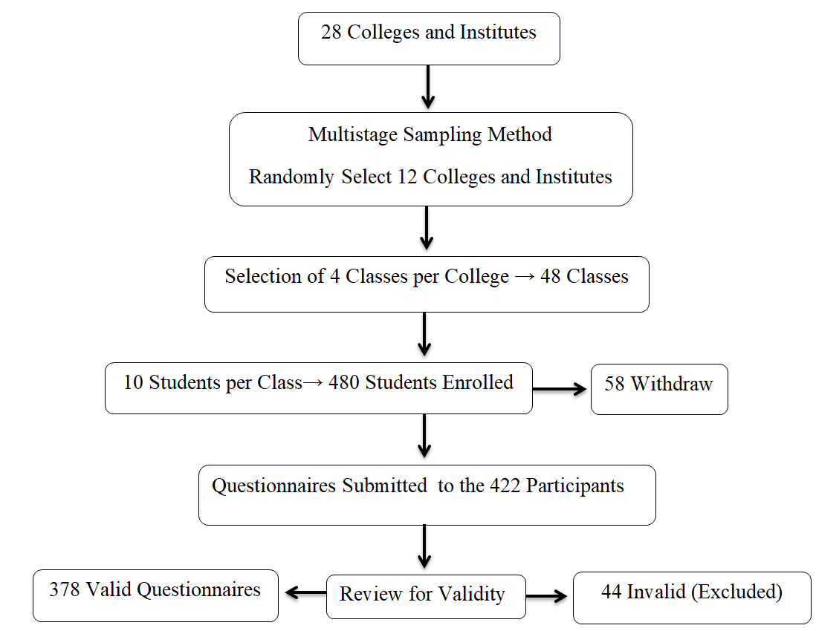
Figure 1: Screening and Recruitment of the Study Participants.
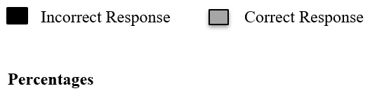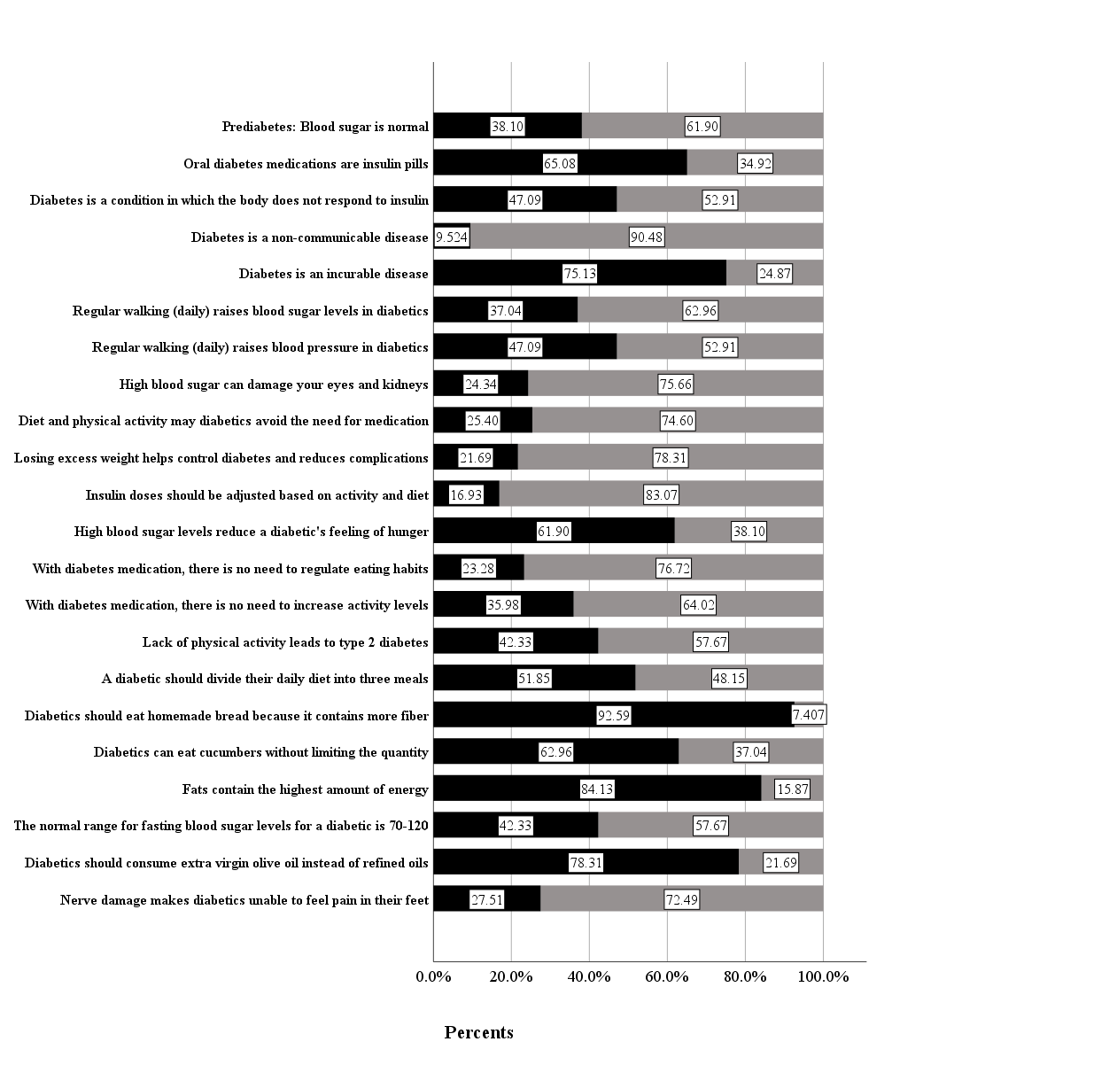
Figure 2: Study participant's responses to knowledge questions.
Figure Legends:
Figure 1: Screening and Recruitment of the Study Participants. A flowchart illustrating the screening, eligibility assessment, and recruitment process for the study. The chart includes key stages, such as initial screening, inclusion/exclusion criteria, and final enrollment, with numbers or percentages indicating participants' progress at each step.

Figure 2: Study participant's responses to knowledge questions. The graph (bar chart) shows a comparison of participants' correct and incorrect answers to knowledge questions about dietary restrictions and food composition. The figure highlights the prevalence of misconceptions or inaccurate knowledge across different food categories.

Tables:
Table 1: Socio-demographic characteristics and some factors of study participants (n=378).
Variable | Category | Frequency (%)
Sex | Male | 192 (50.8)
Sex | Female | 186 (49.2)
Age group (years) | ≤ 22 | 178 (47.1)
Age group (years) | > 22 | 200 (52.9)
Marital Status | Married | 92 (24.3)
Marital Status | Single | 286 (75.7)
BMI Category | Underweight < 18.5 | 14 (3.7)
BMI Category | Normal (18.5–24.9) | 172 (45.5)
BMI Category | Overweight (25–29.9) | 166 (43.9)
BMI Category | Obese (≥30) | 26 (6.8)
Academic year | 1st year | 84 (22.2)
Academic year | 2nd year | 140 (37.0)
Academic year | 3rd year | 76 (20.1)
Academic year | 4th year | 78 (20.6)
Attended courses on T2D | Yes | 84 (22.2)
Attended courses on T2D | No | 294 (77.8)
Have you ever checked BG | Yes | 172 (45.5)
Have you ever checked BG | No | 206 (54.5)
Family history of diabetes | Yes | 170 (45.0)
Family history of diabetes | No | 208 (55.0)
Had experience in the care of T2D | Never | 152 (40.2)
Had experience in the care of T2D | Rarely | 62 (16.4)
Had experience in the care of T2D | Some times | 108 (28.6)
Had experience in the care of T2D | Always | 56 (14.8)
Information sources about T2D | Internet | 158 (41.8)
Information sources about T2D | TV | 20 (5.3)
Information sources about T2D | Friends | 26 (6.9)
Information sources about T2D | Medical staff | 44 (11.6)
Information sources about T2D | Reading | 22 (5.8)
Information sources about T2D | Family | 108 (28.6)
Note: %: percent, T2D: Type 2 Diabetes Mellitus, BMI: Body Mass Index, TV: TelevisionC, BG: Blood Glucose.

Table 2: The relationship between the scores of KAPs and some participants parameters (n=378).
Variable | Category | Knowledge score  (M ±SD) | P-Value | Attitude score  (M ±SD) | P-Value | Practice score  (M ±SD) | P-Value
KAPs | Toal Score | 54.1 ± 15.9 |  | 75.9 ± 12.9 |  | 66.8 ± 13.9
Age group (years) ª | ≤ 22 | 51.9 ± 15.8 | 0.014 | 75.5 ±12.9 | 0.491 | 64.3 ±14.7 | 0.001
Age group (years) ª | > 22 | 55.9 ±15.8 | 0.014 | 76.4 ± 12.7 | 0.491 | 68.9 ± 12.9 | 0.001
Sex ª | Males | 56.4 ± 14.8 | 0.003 | 76.2 ± 12.9 | 0.74 | 70.1 ± 13.6 | 0.000
Sex ª | Females | 51.6 ± 16.7 | 0.003 | 75.7 ± 12.8 | 0.74 | 63.3 ± 13.5 | 0.000
BMI (kg/m²) ^{b} | underweight | 57.2 ± 16.9 | 0.042¹ | 73.8 ±13.4 | 0.470 | 56.6 ±13.3 | 0 .007 ²
BMI (kg/m²) ^{b} | normal weight | 53.2 ± 15.6 | 0.042¹ | 75.0 ±12.6 | 0.470 | 67.4 ±13.9 | 0 .007 ²
BMI (kg/m²) ^{b} | overweight | 53.4 ± 15.9 | 0.042¹ | 77.1 ±12.4 | 0.470 | 66.1 ±13.9 | 0 .007 ²
BMI (kg/m²) ^{b} | obesity | 62.2 ± 15.4 | 0.042¹ | 76.3 ±15.9 | 0.470 | 72.1 ±12.2 | 0 .007 ²
Marital status ª | married | 59.9 ± 14.9 | 0.000 | 75.0 ± 12.1 | 0.429 | 69.5 ± 13.1 | 0.031
Marital status ª | single | 52.2 ± 15.7 | 0.000 | 76.2 ± 13.0 | 0.429 | 65.9 ± 14.2 | 0.031
Academic year | 1st year | 51.2 ± 16.9 | 0.039³ | 77.9 ±12.9 | 0.000⁴ | 67.9 ±14.1 | 0.220
Academic year | 2nd year | 52.9 ± 15.4 | 0.039³ | 73.2 ±13.9 | 0.000⁴ | 67.4 ±13.4 | 0.220
Academic year | 3rd year | 57.8 ± 15.2 | 0.039³ | 74.6 ±11.0 | 0.000⁴ | 63.8 ±13.6 | 0.220
Academic year | 4th year | 55.6 ± 15.8 | 0.039³ | 80.4 ±10.7 | 0.000⁴ | 67.2 ±15.1 | 0.220
Attendance workshops on T2D ª | Yes | 61.5 ±14.6 | 0.000 | 78.8 ±11.6 | 0.027 | 75.9 ±9.9 | 0.000
Attendance workshops on T2D ª | No | 51.9 ±15.6 | 0.000 | 75.2 ±13.1 | 0.027 | 64.1 ± 13.9 | 0.000
checking BG before ª | Yes | 59.4 ±14.5 | 0.000 | 79.1 ±12.7 | 0.000 | 68.7 ±14.2 | 0.014
checking BG before ª | No | 49.6 ±15.7 | 0.000 | 73.3 ±12.3 | 0.000 | 65.1 ±13.6 | 0.014
Family history of T2D ª | Yes | 59.1 ± 14.6 | 0.000 | 77.3 ± 11.9 | 0.070 | 67.7 ± 13.9 | 0.250
Family history of T2D ª | No | 49.9 ± 15.7 | 0.000 | 74.8 ± 13.5 | 0.070 | 66.0 ± 14.1 | 0.250
Had experience in the care of T2D ^{b} | Never | 51.1 ± 15.3 | 0.017⁵ | 73.8 ± 14.6 | 0.039 | 63.7 ± 13.5 | 0.003⁶
Had experience in the care of T2D ^{b} | Rarely | 54.5 ± 17.3 | 0.017⁵ | 77.4 ± 10.1 | 0.039 | 67.3 ± 13.7 | 0.003⁶
Had experience in the care of T2D ^{b} | Some times | 55.8 ± 16.9 | 0.017⁵ | 76.6 ± 11.0 | 0.039 | 69.5 ± 12.8 | 0.003⁶
Had experience in the care of T2D ^{b} | Always | 58.1 ± 12.7 | 0.017⁵ | 78.9 ± 13.0 | 0.039 | 69.2 ± 16.2 | 0.003⁶
Information sources ^{b} | Internet | 52.6 ± 15.5 | 0.075 | 73.7 ± 14.2 | 0.005 ⁷ | 64.9 ± 13.5 | 0.177
Information sources ^{b} | TV | 60.5 ± 11.2 | 0.075 | 74.2 ± 10.4 | 0.005 ⁷ | 64.6 ± 18.9 | 0.177
Information sources ^{b} | Friends | 48.3 ± 16.9 | 0.075 | 76.3 ± 13.7 | 0.005 ⁷ | 67.4 ± 9.9 | 0.177
Information sources ^{b} | Medical staff | 57.0 ± 14.4 | 0.075 | 77.4 ± 10.8 | 0.005 ⁷ | 70.6 ± 14.3 | 0.177
Information sources ^{b} | Reading | 55.8 ± 16.6 | 0.075 | 71.9 ± 13.3 | 0.005 ⁷ | 69.2 ± 12.1 | 0.177
Information sources ^{b} | Family | 54.8 ± 16.9 | 0.075 | 79.6 ± 10.6 | 0.005 ⁷ | - ± 14.4 | 0.177
KAP: Knowledge Attitude and Practice, M: Mean, SD: Standard Deviation, ª: independent sample t-test, b: one-way between group ANOVA, T2D: Type 2 Diabetes, BMI: Body Mass Index, BG: Blood Glucose, TV: Television. The p-value is significant at the 0.05 level.
1: there is a -9.014 difference between the mean of the normal weight group and the mean of the obesity group (p = 0.042). Likewise, there is a -8.842 difference between the mean of the overweight group and the mean of the obesity group (p = 0.048).
2: there is a -10.747 difference between the mean of underweight group and the mean of the normal weight group (p = 0.032). Likewise, there is a -15.483 difference between the mean of underweight group and the mean of the obesity group (p = 0.005).
3: there is a -6.585 difference between the mean of the first-year group and the mean of the third group (p = 0.051).
4: there is a 4.657 difference between the mean of the first-year group and the mean of the second-year group (p = 0.048). Likewise, there is a –5.844 difference between the mean of the third-year group and the mean of the fourth-year group (p = 0.027). In contrast, there is a –7.217 difference between the mean of the second-year group and the mean of the fourth-year group (p = 0.000).
5: there is a -6.981 difference between the mean of the never-care diabetes patient group and the mean of the always-care diabetes patient group (p = 0.029).
6: there is a -5.859 difference between the mean of never-care a diabetes patient group and the mean of some time-care a diabetes patient group (p = 0.005).
7: there is a -5.945 difference between the mean of information sources by the internet group and the mean of the information sources by the family group (p = 0.003).

Table 3: Study participants' responses to attitudes and practices (n = 378)
Attitudes | Category | Frequency (%)
My assessment of T2D and its impact on health | Very dangerous | 6 (1.6)
My assessment of T2D and its impact on health | Dangerous | 20 (5.3)
My assessment of T2D and its impact on health | Not dangerous | 162 (42.9)
My assessment of T2D and its impact on health | No effect | 190 (50.3)
My assessment of the impact of T2D on people my age | Very dangerous | 8 (2.1)
My assessment of the impact of T2D on people my age | Dangerous | 70 (18.5)
My assessment of the impact of T2D on people my age | Not dangerous | 178 (47.1)
My assessment of the impact of T2D on people my age | No effect | 122 (32.3)
My assessment of my likelihood of developing T2D | High | 32 (8.5)
My assessment of my likelihood of developing T2D | Middle | 136 (36.0)
My assessment of my likelihood of developing T2D | Low | 160 (42.3)
My assessment of my likelihood of developing T2D | Nill | 50 (13.2)
Practices | Category | Frequency (%)
I control my weight to reduce my risk of developing T2D | Never | 72 (19.0)
I control my weight to reduce my risk of developing T2D | Rarely | 76 (20.1)
I control my weight to reduce my risk of developing T2D | Most times | 160 (42.3)
I control my weight to reduce my risk of developing T2D | Always | 70 (18.5)
I exercise to reduce my risk of developing T2D | Never | 36 (9.5)
I exercise to reduce my risk of developing T2D | Rarely | 68 (18.0)
I exercise to reduce my risk of developing T2D | Most times | 160 (42.3)
I exercise to reduce my risk of developing T2D | Always | 114 (30.2)
I eat a balanced and varied diet that contains less glucose | Never | 54 (14.3)
I eat a balanced and varied diet that contains less glucose | Rarely | 113 (29.9)
I eat a balanced and varied diet that contains less glucose | Most times | 147 (38.9)
I eat a balanced and varied diet that contains less glucose | Always | 64 (16.9)
I talk to a healthcare professional to get information about T2D | Never | 104 (27.5)
 | Rarely | 109 (28.8)
 | Most times | 108 (28.6)
 | Always | 57 (15.1)
I rely on accurate health information to change my lifestyle regarding T2D | Never | 46 (12.2)
 | Rarely | 69 (18.3)
 | Most times | 166 (43.9)
 | Always | 97 (25.7)
I am considering changing my lifestyle to reduce my risk of developing T2D | Never | 54 (14.3)
 | Rarely | 65 (17.2)
 | Most times | 165 (43.7)
 | Always | 94 (24.9)
I follow news related to T2D. | With great interest | 45 (11.9)
I follow news related to T2D. | With interest | 93 (24.6)
I follow news related to T2D. | No interest | 194 (51.3)
I follow news related to T2D. | Avoid it most times | 46 (12.2)
Note: %: percentage, T2D: type 2 diabetes

Table 4: Associated factors of knowledge, attitudes, and practices among university students (n = 378)
Model (Knowledge) | B  (95% CI) | β | R² | Adjusted R² | t | p-value
Present of family history of T2D | 8.475 | 0.267 | 0.092 | 0.090 | 5.745 | 0.000
Students have no checked blood glucose | -7.158 | -0.225 | 0.166 | 0.161 | -4.641 | 0.000
Married student | 4.950 | 0.133 | 0.194 | 0.188 | 2.835 | 0.005
Students in the third academic year | 5.777 | 0.147 | 0.211 | 0.202 | 3.169 | 0.002
Male gender | 4.202 | 0.133 | 0.226 | 0.216 | 2.887 | 0.004
Students have not attended a workshop on T2D | -4.071 | -0.106 | 0.235 | 0.223 | -2.181 | 0.030
Friends are a source of information about T2D | -6.201 | -0.100 | 0.245 | 0.230 | -2.156 | 0.032
Model (Attitudes) | B  (95% CI) | β | R² | Adjusted R² | t | p-value
Students have checked blood glucose before | 5.033 | 0.196 | 0.048 | 0.046 | 3.968 | 0.000
family is a source of information about T2D | 5.598 | 0.199 | 0.082 | 0.077 | 4.048 | 0.000
Students in the second academic year | -3.328 | -0.126 | 0.110 | 0.102 | -2.367 | 0.018
Students in the fourth academic year | 3.502 | 0.110 | 0.120 | 0.110 | 2.054 | 0.041
Model (Practices) | B  (95% CI) | β | R2 | Adjusted R² | t | p-value
Students have not attended a workshop on T2D | -12.596 | -0.372 | 0.111 | 0.109 | -7.764 | 0.000
Male gender | 5.357 | 0.192 | 0.162 | 0.157 | 4.000 | 0.000
Students in the first academic year | 8.179 | 0.245 | 0.177 | 0.170 | 4.375 | 0.000
Students in the second academic year | 5.220 | 0.181 | 0.195 | 0.187 | 3.432 | 0.001
Underweight status | -8.477 | -0.116 | 0.209 | 0.199 | -2.497 | 0.013
Age of the student | 0.329 | 0.127 | 0.222 | 0.210 | 2.461 | 0.014
B = unstandardized Coeffcients, CI = confidence interval, B =standardized Coeffcients, R² = the proportion of variance in the criterion, t = t-statistic, T2D = type 2 diabetes. Reference categories = 0. The p-value is significant at the 0.05 level.

